**Issue 6**: Shipping Address is not present; if the payment screen is a part of an online shopping site

**Description**: If the screen is part of an online shopping site, then we need to include shipping address as well. Because the billing address and shipping address can be different.

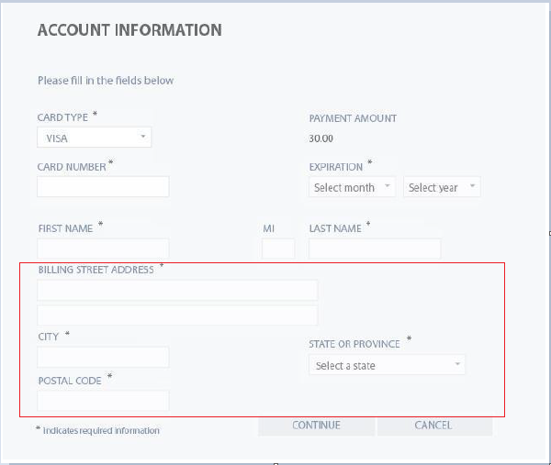

**Expected Behavior**: The billing and shipping address should be present if the screen is part of an online shopping site

**Severity**: Major